Lab 6 Output File
Q1.
(a) Area under f(x) = -0.400000
(b) Area under f(x) = 0.000000
(c) Area under f(x) = 0.243195
(d) Area under f(x) = 0.367879

Q2.
Error bound in (a) = 1.138889 Actual Error = 0.333969
Error bound in (b) = 9.674078 Actual Error = 2.588629
Error bound in (c) = 0.318701 Actual Error = 0.263572
Error bound in (c) = 0.135335 Actual Error = 0.095366

Q3.
(a)
By Midpoint rule, estimated value is -0.67532.
Bound for error by error formula is 0.28086.
Actual error is 0.05864.
By Trapezoid rule, estimated value is -0.86667.
Bound for error by error formula is 0.56173.
Actual error is 0.13270.
By Simpsons rule, estimated value is -0.73911.
Bound for error by error formula is 0.06328.
Actual error is 0.00514.
By Corrected Trapezoidal rule, estimated value is -0.71019.
Bound for error by error formula is 0.25312.
Actual error is 0.02378.

(b)
By Midpoint rule, estimated value is 1.80391.
Bound for error by error formula is 1.14940.
Actual error is 0.78471.
By Trapezoid rule, estimated value is 4.14326.
Bound for error by error formula is 2.29881.
Actual error is 1.55463.
By Simpsons rule, estimated value is 2.58370.
Bound for error by error formula is 0.12679.
Actual error is 0.00493.
By Corrected Trapezoidal rule, estimated value is 2.61901.
Bound for error by error formula is 0.50715.
Actual error is 0.03039.

(c)
By Midpoint rule, estimated value is -0.01190.
Bound for error by error formula is 0.04004.
Actual error is 0.00848.
By Trapezoid rule, estimated value is -0.03702.
Bound for error by error formula is 0.08007.
Actual error is 0.01665.
By Simpsons rule, estimated value is -0.02027.
Bound for error by error formula is 0.00249.
Actual error is 0.00011.
By Corrected Trapezoidal rule, estimated value is -0.00273.
Bound for error by error formula is 0.00998.
Actual error is 0.01765.

(d)
By Midpoint rule, estimated value is 0.26584.
Bound for error by error formula is 0.22566.
Actual error is 0.00668.
By Trapezoid rule, estimated value is 0.28633.
Bound for error by error formula is 0.45133.
Actual error is 0.01382.
By Simpsons rule, estimated value is 0.27267.
Bound for error by error formula is 0.04359.
Actual error is 0.00016.
By Corrected Trapezoidal rule, estimated value is 0.15184.
Bound for error by error formula is 0.17436.
Actual error is 0.12067.

Q4.
Estimate of pi using
(a) Trapezoid Rule = 3.000000 Error = 0.141593
(b) Simpson one-third rule = 3.466667 Error = 0.325074
(c) Midpoint rule = 3.200000 Error = 0.058407
(d) Simpson three-eigth rule = 3.138462 Error = 0.003131

Q5.
(a)
f = (x)x^2*exp(-x^2)
Estimate of integral = 0.421582 Actual Error = 0.001143

(b)
f (x) = 1/(x*log(x))
Estimate of integral = 0.440345 Actual Error = 0.001158

(c)
f (x) = x^2*log(x^2+1)
Estimate of integral = 3.159476 Actual Error = 0.050185

(d)
f (x) = (sin(x))^2-2*x*sin(x)+1
Estimate of integral = -0.489323 Actual Error = 0.000303

Q6.
(a)
f (x) = x^2*exp(-x^2)
Estimate using composite Midpoint = 0.423296 using composite Simpson = 0.422725

(b)
f(x) = 1/(x*log(x))
Estimate using composite Midpoint = 0.438609 using composite Simpson = 0.439187

(c)
f(x) = x^2*log(x^2+1)
Estimate using composite Midpoint = 3.084203 using composite Simpson = 3.109294

(d)
f(x) = (sin(x))^2-2*x*sin(x)+1
Estimate using composite Midpoint = -0.488867 using composite Simpson = -0.489019

Q7.
(a)
Number of sub-intervals to get error < 10⁻⁵/2 = 3
Approximate Integral = 3.141592
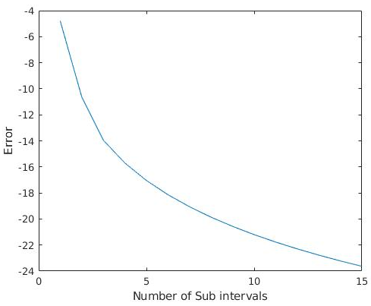

Number of sub-intervals to get error < 10⁻⁵/2 = 4
Approximate Integral = 0.392695
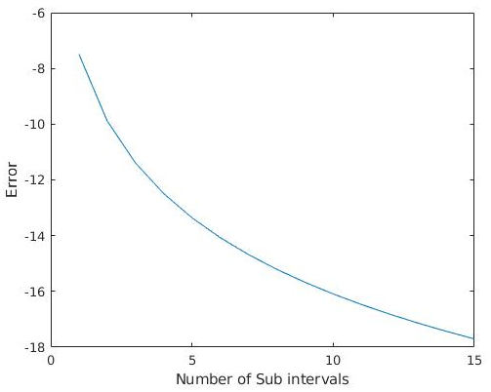

Q8.
Area under f(x) using composite Trapezoid = 7.125000

Q9.
(a) Approximation using Composite Trapezoid = 0.636304 n = 77.000000 h = 0.012987
(b) Approximation using Composite Simpson = 0.636298 n = 3.000000 h = 0.333333
(c) Approximation using Composite Midpoint = 0.636284 n = 54.000000 h = 0.018519

Q10.
length of the graph of the ellipse = 7.611639

Q11.
Length of the track = 9855.000000 feet

